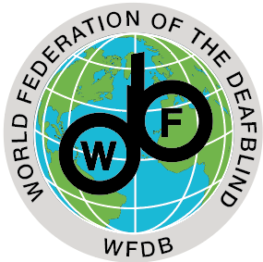

1st Announcement 28.02.2020

Invitation for the 6th World Federation of the Deafblind (WFDB) General Assembly and the 12th Helen Keller World Conference (HKWC) September /October 2021

WFDB hereby invites you to the 6th General Assembly and the 12th HKWC in Nairobi, Kenya from September 28th to October 5 th 2021.
Meetings at the General Assembly are open and consist of deafblind representatives from national members of the WFDB. See the WFDB constitution Article 5: General assembly.
Information about nominations and nomination forms for the different positions in WFDB will be sent out in later announcements. Applications and motions to be considered by the General Assembly must be received by the Executive Council at least twelve (12) months before the date of the General Assembly by mail to: wfdb@wfdb.eu.
The agenda and all relevant documents related to the General Assembly will be sent to the members at least four (4) months before the date of the meeting.
The WFDB events will be held prior to the 1st African DeafBlind International (DbI) Conference on Deafblindness in Nairobi, Kenya from October 6 th to 8 th 2021. The African Researchers' Initiative (ARI) will present their research on deafblindness at the DbI conference.
Co-organisation of the WFDB and DbI events facilitates the participation of persons with deafblindness who wish to attend both events. Furthermore, it will ensure a wider presence of UN agencies based in Kenya, the African Union, and other key organisations.

Preliminary program of events:
Day 1: Tuesday, September 28th: Workshop & African Federation of the Deafblind (AFDB) General Assembly, Other Regional meetings
Day 2: Wednesday, September 29th: WFDB General Assembly
Day 3: Thursday, September 30th: WFDB General Assembly
Day 4: Friday, October 1st: No One Left Behind Day (NOLB)
Day 5: Saturday, October 2nd: Field visit
Day 6: Sunday, October 3rd: HKWC
Day 7: Monday, October 4th: HKWC
Day 8: Tuesday, October 5th: HKWC

Please note that there may be slight changes in the dates and program above. Further information about the venue, accommodation, expenses, and package deals for all events, together with an updated program, will be included in our 2nd announcement, within the third quarter of 2020.

Conference theme:
The main theme of HKWC will be: Empowering persons with deafblindness – Inclusion through investment and innovation. Please see “Call for Application” for more information on how to hold plenary and workshop sessions, and a more detailed description of the main theme and subthemes of the conference. The Submission deadline for applications to hold plenary and/or workshop presentations at the HKWC 2021 is December 31st, 2020.

Welcome to the 6th WFDB General Assembly and the 12th HKWC 2021.

Best regards,
Geir Jensen
President.

